Name: Varsha Veernapu

Roll No:20NN1A05B7

College: Vignan’s Nirula Institute Of Technology And Science For Women, Pedapalakaluru,Guntur.

Email id: [veernapuvarsha@gmail.com](mailto:veernapuvarsha@gmail.com)

Contact : +91 7288910874

Title: Creating a RESTful API using express.js and creating a database and index in MongoDB

source code :

index.js:

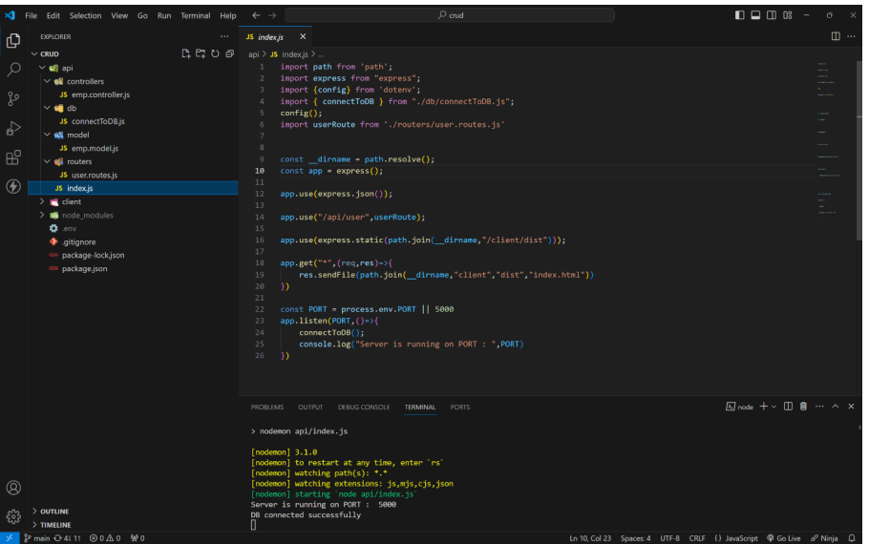

MongoDB Connection:

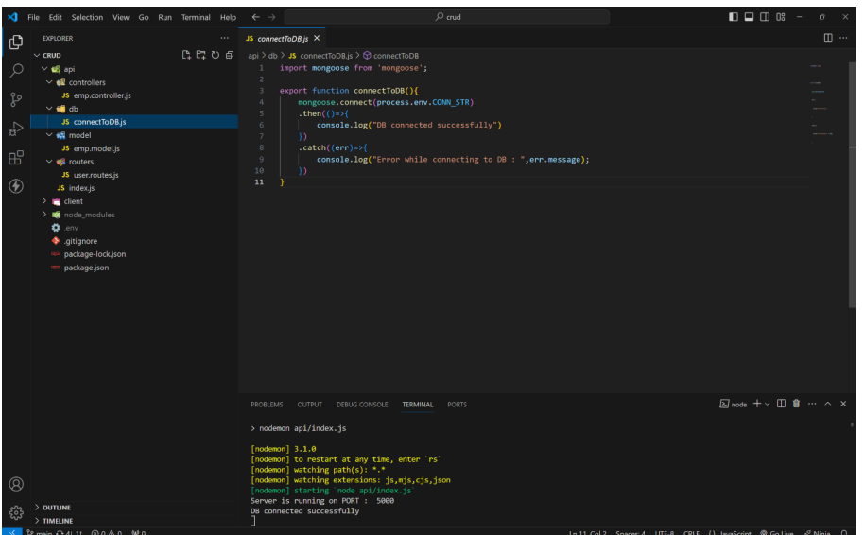

Model:

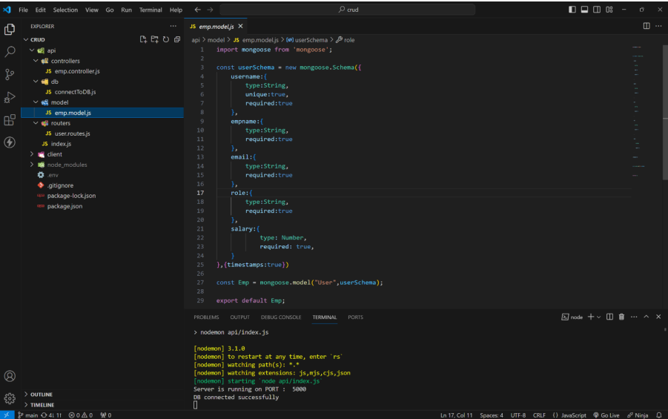

Routes:

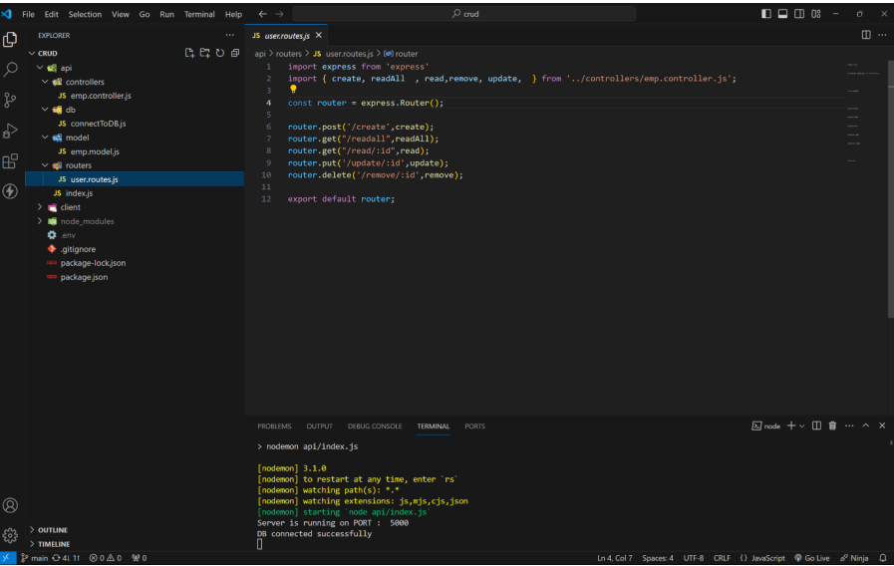

Controllers:

Create:

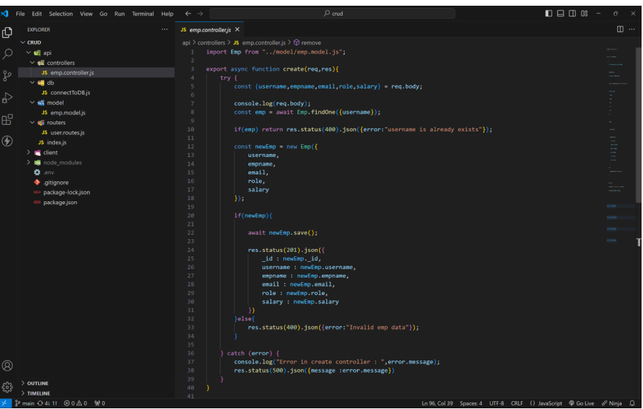

Read all:

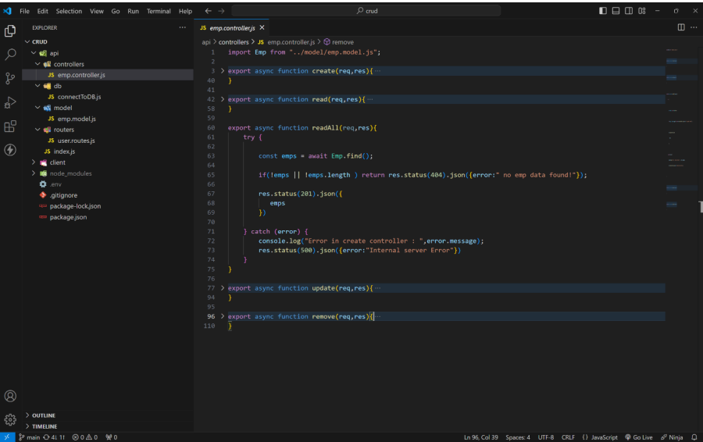

Readdone:

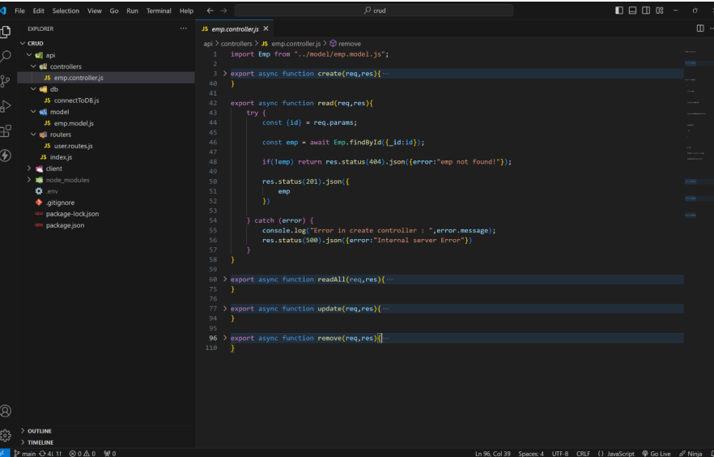

Update:

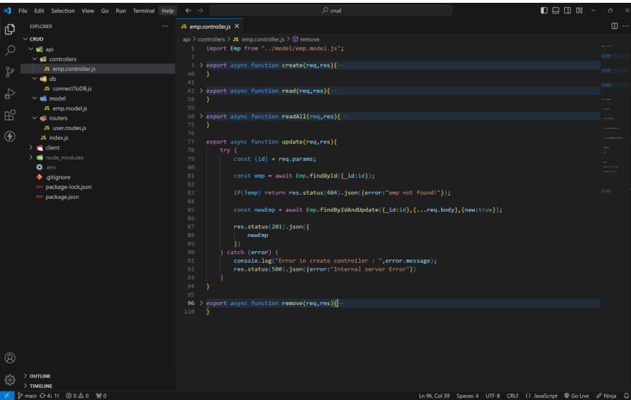

Delete:

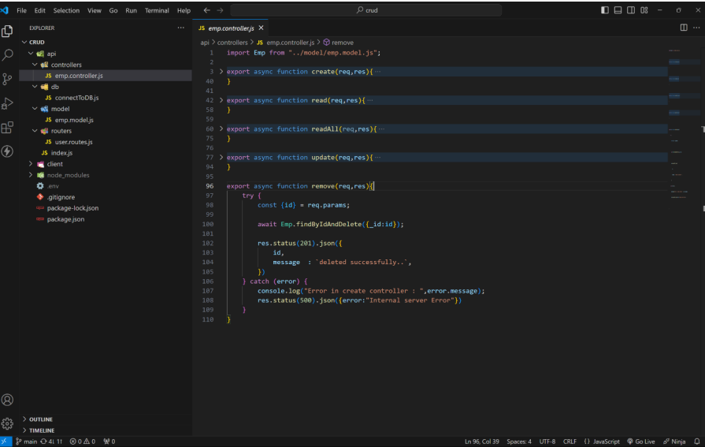

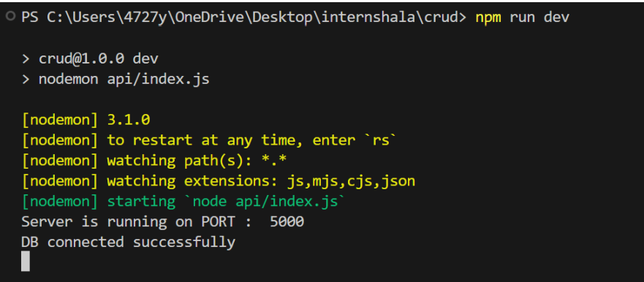

Route and its functionality :

CREATE ROUTE : 1 . This route is used to create a new employee in database with a below fields.

username, empname, email, role, salary

2 . To click on new request and select this options method as post

url as <http://localhost:5000/api/user/create>

pass this json data as a body as your required value.

{

"username": "jack",

"empname": "jack rider",

"email": "jack@gmail.com",

"role": "Front End Developer",

"salary": 60000

}

3 . finally press send to insert data in mongodb data base and get a inserted data as a response.

4 . If user is already in db it will return User is already exist as response. for more details visit below output images...

READONE :

1 . This route is used to read specific user info by passing that user id as a param. method as get url as http://localhost:5000/api/user/read/65ed7b3d76e1dcc9a51654ca

2 . After sending you will get that specific user details as response.

READALL :

1 . Read all route is used to get all the user data existing in the mongodb data base .

method as get url as <http://localhost:5000/api/user/readall>

2 . After sending you will get that all user details as response.

UPDATE :

1 . This route is used to update specific user by passing that user id as a param

method as put url as http://localhost:5000/api/user/update/65ed7b3d76e1dcc9a51654ca

2 . After sending you will get updated user details as response.

DELETE :

1 . This route is used to delete specific user by passing that user id as a param.

method as delete url as <http://localhost:5000/api/user/delete/65ed7b3d76e1dcc9a51654ca>

2 . After sending you will deleted successfully as response

Output:

Create a new user:

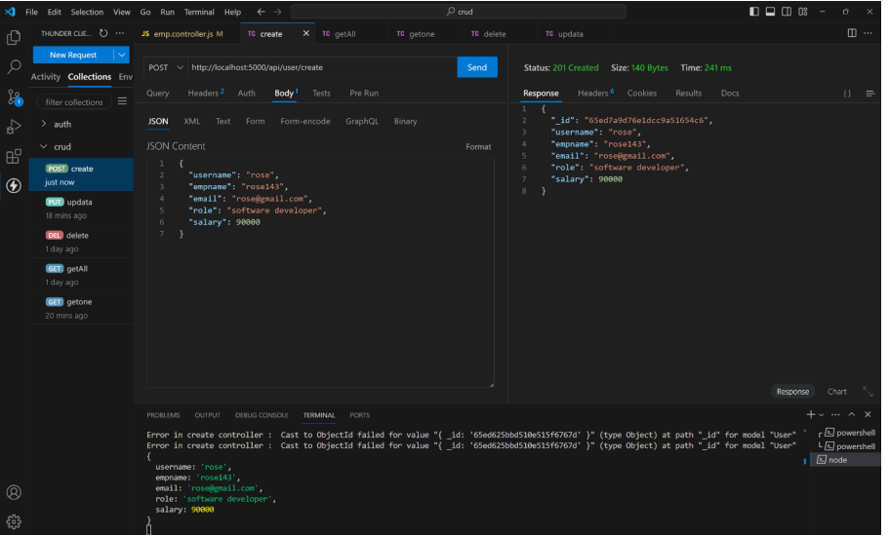

CREATING USER WITH EXISTING USERNAEME:

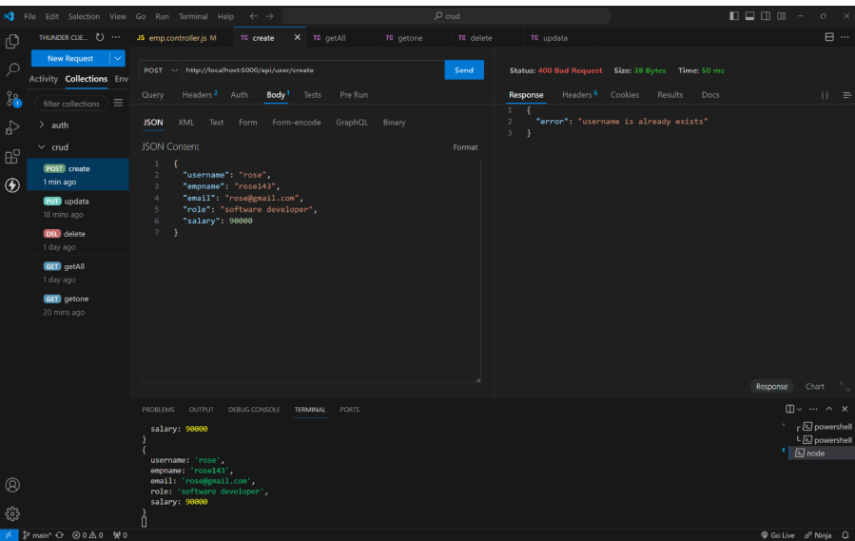

READONE :

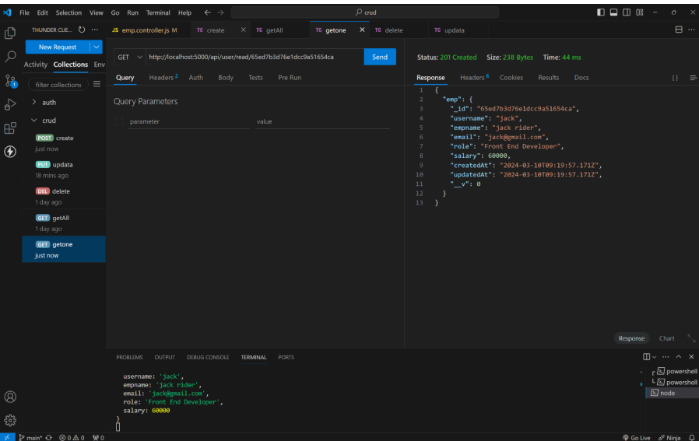

READ ALL :

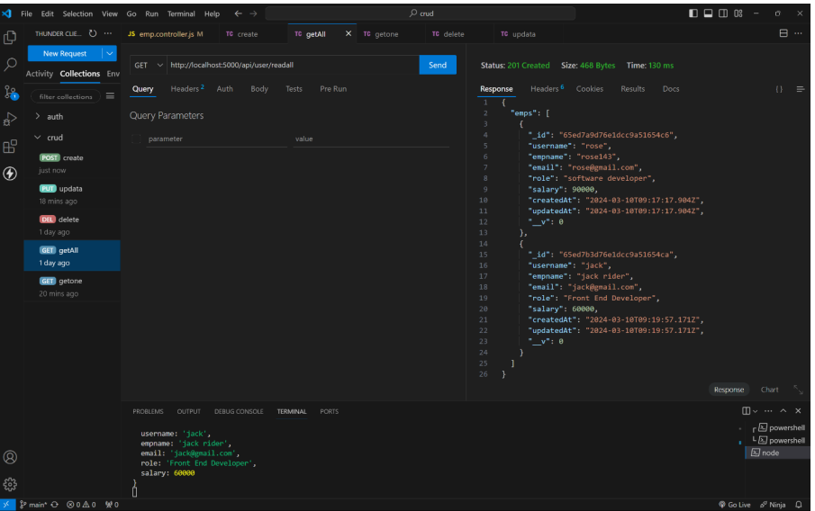

UPDATE :

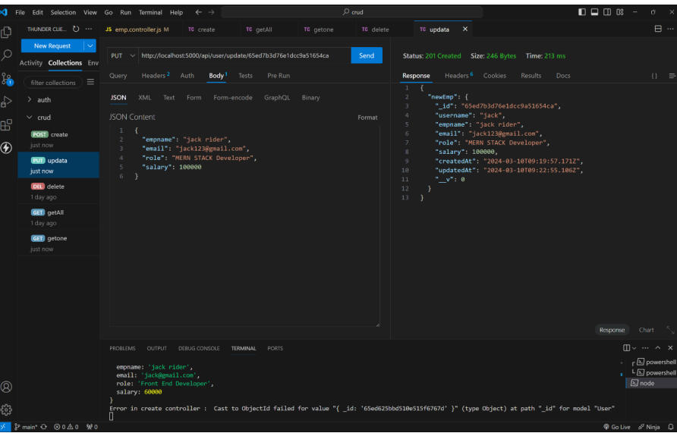

DELETE :

